30th Annual Learning Fair VENDOR APPLICATION
Thursday and Friday, JULY 11 & 12, 2024 Event Location: Northwest Elementary School 3757 Lansing Ave.
Jackson, MI 49202
www.Learningfair.org
Business Name Contact Name Address City State Zip Business Phone Home Phone
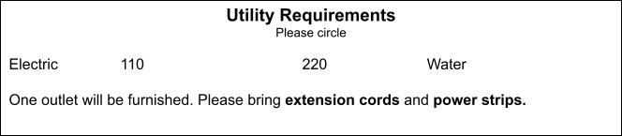
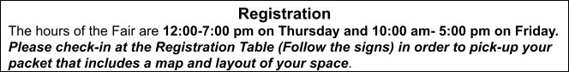
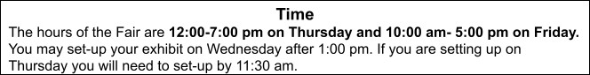
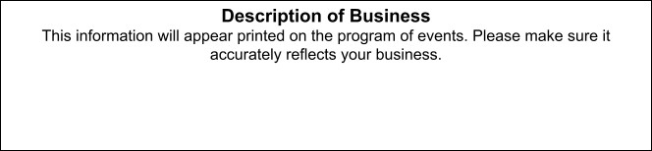
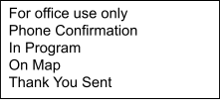Fax E-Mail Address
Description of Exhibit
This information will appear in the program of events. Please make sure it accurately reflects your exhibit.

