30th Annual Learning Fair EXHIBITOR APPLICATION
Thursday and Friday, JULY 11 & 12, 2024 Event Location: Northwest Upper Elementary School
3757 Lansing Ave.
Jackson, MI 49202
www.Learningfair.org

Business Name Contact Name Address City State Zip Business Phone Home Phone
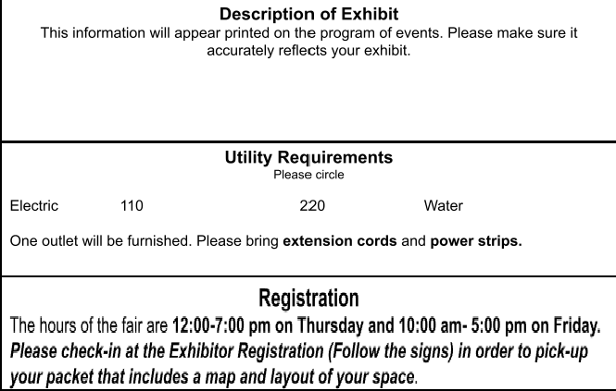Fax E-Mail Address

